Bumacod E-Jhay’s Group

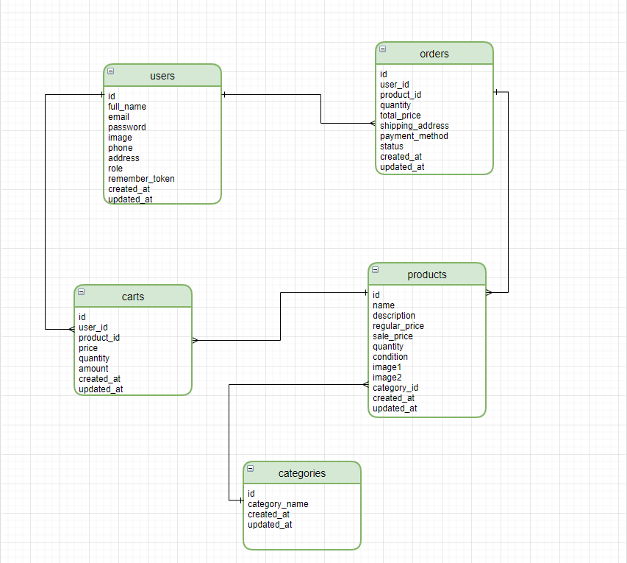**Entity Relationship Diagram**

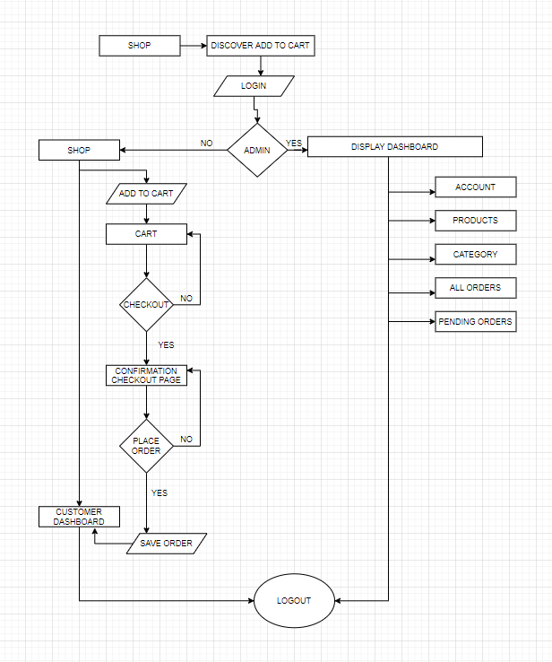**FlowChart**